# Saif Group Pvt Ltd Shines at Expo Real Estate Riyadh 2024

[Saif Group Pvt Ltd](http://www.thesaifgroup.com/) participated as an exhibitor at the prestigious Expo Real Estate, which took place in Riyadh, Saudi Arabia, on the 4th and 5th of October 2024. Saif Group’s presence at this noteworthy gathering of prominent personalities in the real estate sector was one of its salient features.

A moment of exhilaration was witnessed during the Opening Ceremony whereby the Chairman of Saif Group Pvt Ltd, Aziz Ullah Marwat, and his Chief Executive Officer, Kaleem Ullah Marwat cut a ribbon to open their stall. This event was blessed by the owners of Zam Zam Properties who are affectionately referred to as Choty Bhai and Bary Bhai. Their joint participation signified a constructive partnership between two of the best known personalities in the real estate business.

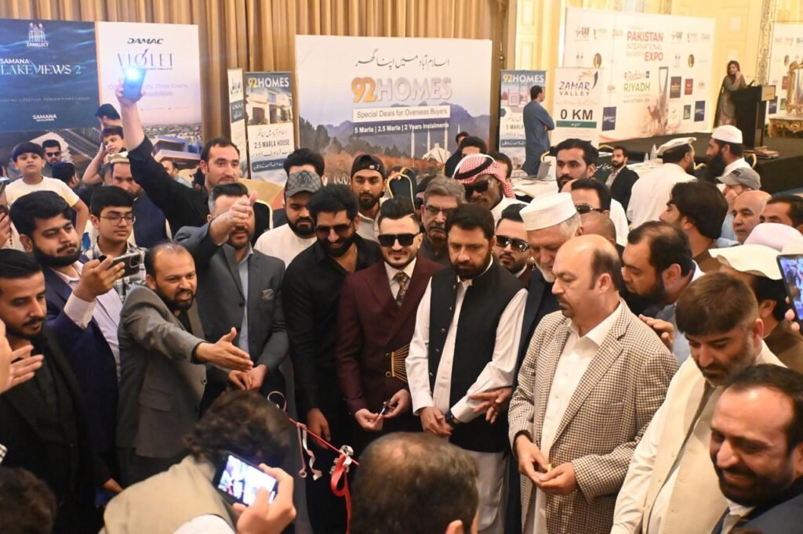

During the event, Saif Group’s’ CEO Kaleem Ullah Marwat, together with some sales managers, showcased Seif Group’s future and current real estate projects by addressing the audience. They offered great explanations to new potential clients, real estate investors, and all the participants. Their projects attracted much attention as thrived on affordability, innovation, and sustainability, the main features that have led Saif Group Pvt Ltd to the industry’s top.

 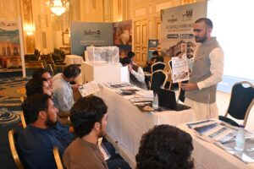

More excitement was there on the last day of the expo with a high profile lucky draw. As pledged, Saif Group Pvt Ltd conducted a pack exciting prize distribution ceremony. The prizes, as promised, were:

* 1st Prize - A brand new car
* 2nd Prize - An iPhone 16 Pro Max
* 3rd Prize - An iPhone 16 Pro

Chairman Aziz Ullah Marwat and CEO Kaleem Ullah Marwat personally presented the prizes to the fortunate winners, ensuring the event concluded on a high note and leaving a lasting impression of Saif Group’s dedication to its clientele and community.

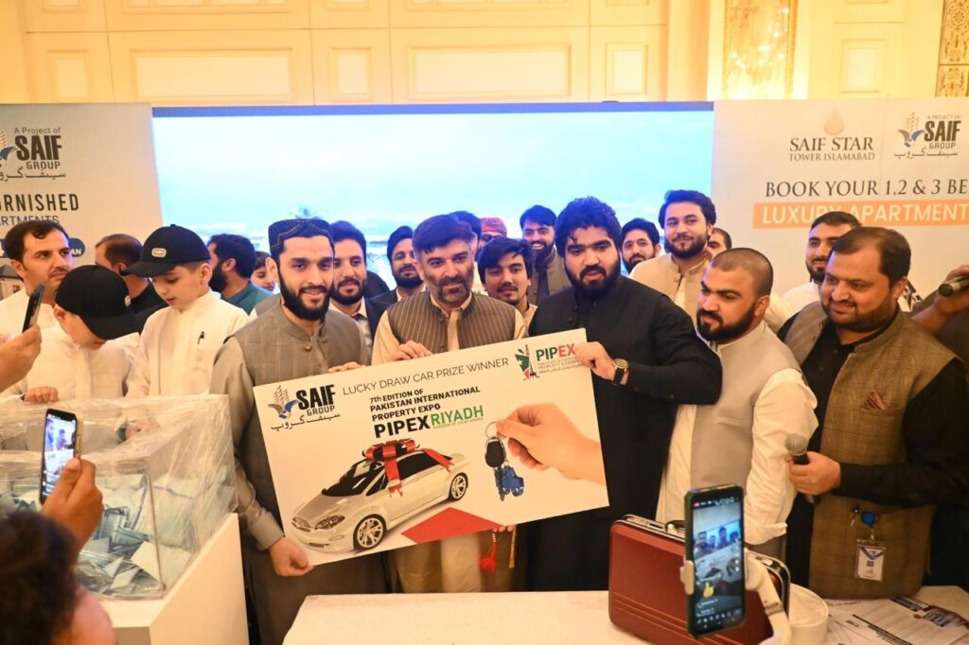

Saif Group Pvt Ltd's involvement in Expo Real Estate Riyadh demonstrated their expanding domestic and global clout in the real estate industry. Saif Group's continued status as a reputable and prominent name in the sector was guaranteed by their effective presence and the captivating events.

**Stay tuned for more exciting updates from Saif Group Pvt Ltd!**